Please read the complete email before proceeding with New Hire Registry (NHR)submission



**New Hire Registry (NHR)**

**Guidance document for** **Deloitte New Hire Registry**

* Please use your personal laptop/desktop to complete New Hire Registration (NHR) process. Do not use a mobile phone to access the NHR survey link.
* Please complete NHR in one single session. In case you are unable to complete it in one go, the system will log you out. (Please clear the cache/cookies and saved passwords and try to login again using the same link to resume the process)
* Updating the Permanent Account Number (PAN) card and Aadhaar card with complete date of birth details are mandatory. Non-submission of PAN card would result in a high amount of taxation on your payroll with Deloitte. Non-submission of Aadhaar card with complete date of birth will lead to delay in your onboarding formalities, logistics and payroll.
* If you do not have a PAN card or Aadhaar card with complete date of birth, please apply for the same at the earliest, and update it in the NHR portal.

Please click on New Hire Registry **link** mentioned in the mail to proceed further

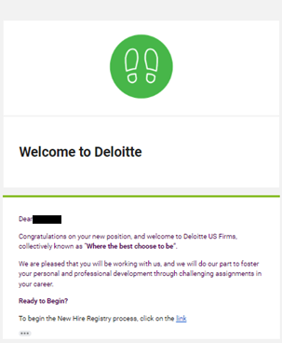

**Account Sign in**

Please enter personal email address on which you received the invitation mail and click on **Next**.

Please enter your password that was created during the Account registration and click on **Next**

Enter the access code that you received on your Phone.

Enter the OTP code that you received on your Phone or the one from the Authenticator app basis your preferred method in MFA (Multi- factor Authentication).

Your account will be verified after successfully entering the code. Please click ‘**Verify’** to continue.

**Deloitte New Hire Registry**

After successful verification, you will be redirected to the New Hire Registry landing page

Click on ‘Proceed to Deloitte New Hire Registry’ to continue.

Great! You have successfully logged into New Hire Registry!

In all the following screens, click on the ‘**Edit this Information’** button on the top- right corner of your screen. Make any required changes and click on the ‘**Save’** button in the bottom-left corner.

**Filling the NHR form.**

Please only update the fields marked as **‘*Required Information**’ in the form and click on ‘**Save’** button.

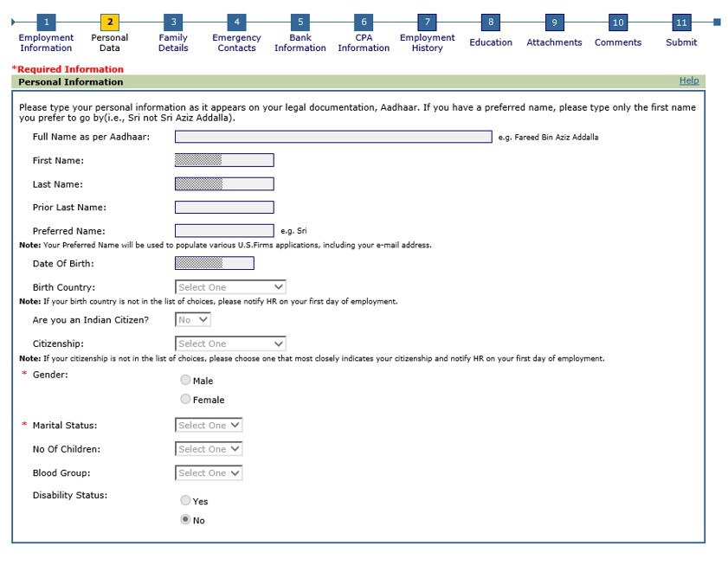

If you receive an error message regarding the citizenship field, please edit the “Are you an Indian” field and then try to edit the “Citizenship” field again and click on the ‘**Save’** button.

If you are unable to update your email id, please select the check box for address ‘**same as permanent address**’ and update the current address in comments tab.

For E-mail Address, please update your **personal mail id**.

For Cell/Primary Phone number, prefix **+91** when you update.

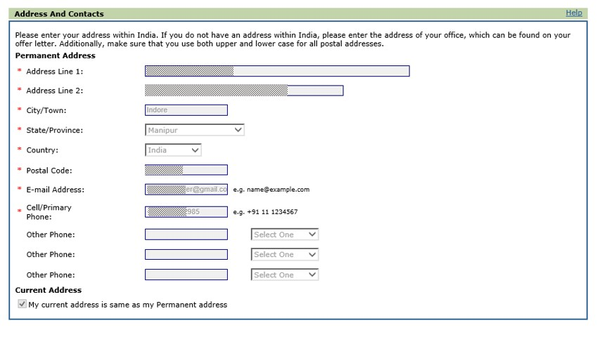

Enter your PAN and Aadhaar details and click on the ‘**Save’** button.

These are mandatory for setting up your payroll and provident fund processes.

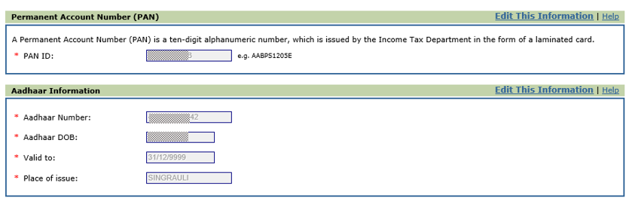

Click on Next page to continue further.

**Family Details**

Fill in your **father’s details for PF purposes**. Confirm that the date of birth of your father is correct. Father’s name should be as per the details on your Aadhaar card. Click on **Save** button.

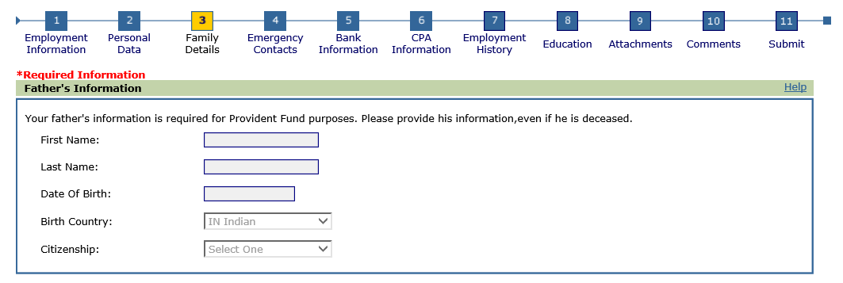

Click on Next page to continue further

**Emergency Contacts**

Fill in one emergency contact. Additional contacts can be added after you join the firm.

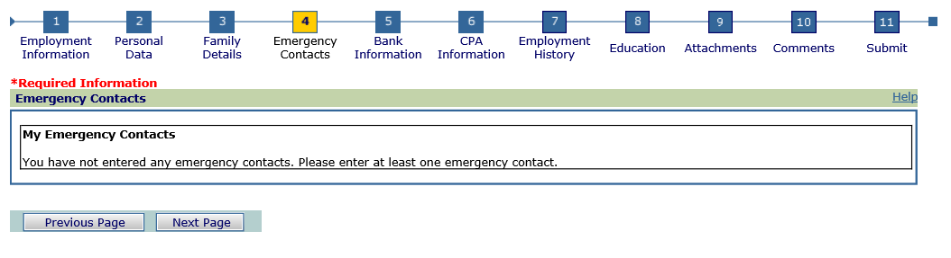

Click on the ‘**Next Page’** button.

**Bank Information**

Kindly enter the details of your bank account including the ‘0’ prefix(zeros).

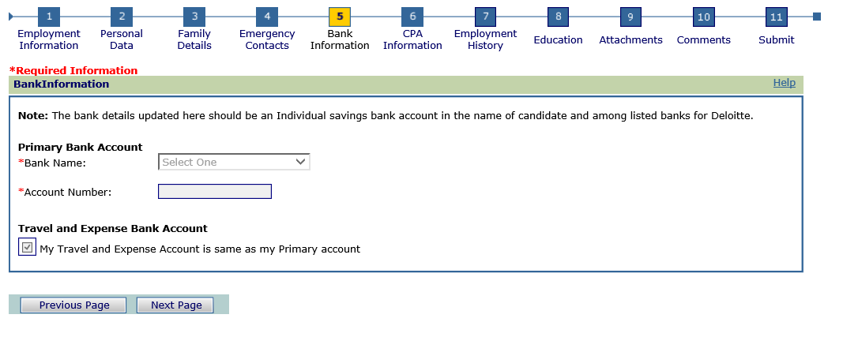

**IMPORTANT:**

* You must hold a bank account ONLY with Deloitte listed Banks as reflecting in the dropdown option. Kindly refer to ‘**earlier email received from EW-Offer management with subject** _**Deloitte India (Offices of US) in India - Recruitment Process - Pre-Hire Survey**’ that includes contact details for each of the Deloitte listed banks. You can reach out to these contacts for any business purposes.
* Kindly ensure that you furnish ONLY your individual savings bank account information (must be out of the listed banks for Deloitte) and not that of your parent’s/friend’s/sibling’s etc. Furnishing the bank account details of other individuals is against the firm’s guidelines/policies, as your salary cannot be transferred to any other individual’s bank account.
* Kindly ensure your individual savings bank account is valid and is active at the time of joining, for timely credit of your salary every month.
* Please ensure that you do not enter any dummy/invalid account number in this field.

Click on the ‘**Next Page’** button.

**Employment History**

Prior Employment

Select ‘**Yes, I have been employed by the Deloitte US Entities**’, only if you had worked with Deloitte US India offices.

Select ‘**No, I have not been employed by the Deloitte US Entities**’, if you had not worked with Deloitte US India offices.

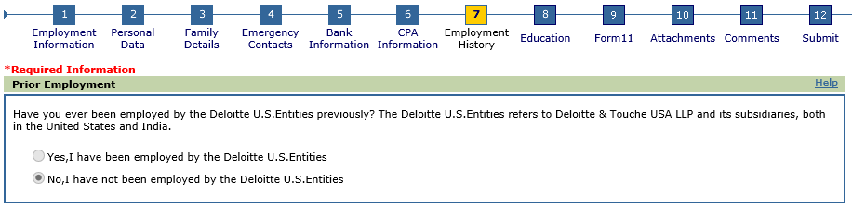

**Experienced Hires:**

•If you are an experienced hire, enter your Universal Account Number (UAN), total work experience and relevant work experience in the below fields. If you already have an existing Universal Account Number (UAN), enter the details in UAN field as shown above. If you do not know your UAN number, please reach out to your previous employer asking for the same.

•Please make sure to provide correct UAN as provided by your previous employer. Providing incorrect UAN details may delay the process of completing Provident Fund requirements.

•If you don’t have any prior experience, edit the Experience field to ‘**0**’and fill in the UAN number with **121212121212,** also please make sure to mention the reason for same in the comments section to avoid any issues as you move further.

***Note:*** *Employment history and education fields are optional.*

If you do not have the education data available handy, or if the New Hire Registry is not accepting the data you are trying to enter, please skip the table below and proceed to the next page.

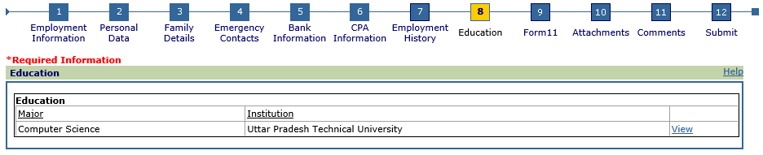

**Form 11**

* Form 11 is a mandatory document which needs to be submitted by all new hires for the creation or linking of your UAN on the EPFO/ UAN member portal.
* Refer the guidance document below to know the steps.



* If you hold a valid passport provided by any country other than India, Nepal, and Bhutan. Kindly select your International worker status as ‘**Yes**’ and select the passport provided country details from the drop-down list.
* If you do not hold a UAN/PF account, then update the details as below.
  + - * Previous PF Account Number**: 12/121/12121/121/121212**
      * UAN**: 121212121212**
* Date of exit from previous employment should be provided in DD/MM/YYYY format.
  + - * Note: If you have prior experience, kindly enter the correct exit date from previous employment.
* After filling all mandatory fields, take a printout of the page by clicking on ‘**Print’** button.
* Kindly note ‘**DECLARATION BY THE PRESENT EMPLOYER**’ on Form 11 is for Deloitte purposes only.
* If you are using the Internet Explorer browser, refer to the screenshot below for steps to take a printout.
* Select ‘**Print on form 11 tab**’ -> new tab pop-up -> right click on new tab -> click on option ‘**Print’.**Graphical user interface, application

  Description automatically generated

**Please upload mandatory documents mentioned in the attachments tab:**

1. **Aadhaar**

• Kindly upload your latest e-Aadhaar copy downloaded from UIDAI portal.

• Please ensure Personal data is as per Aadhaar. In case of any data mismatch (i.e., incorrect name, incomplete DOB (only year of birth updated in UIDAI records) and incorrect gender) in Aadhaar records, we suggest you get the details corrected in Aadhaar records 30 days before your date of joining.

• Kindly check if your Aadhaar is linked with your registered phone number to receive OTP details from EPFO portal, if not kindly get your Aadhaar linked with phone number 20 days before your date of joining.

1. **PAN Card**
2. **Form 11:** After filling all the mandatory fields, take print out of the Form 11 sign the document and upload it.
3. **Self-Declaration letter – Double click on the below image to download and fill the Self Declaration Form.**



* Tick the check box as applicable in the declaration letter (Campus hire/ Experienced hire). Refer to the guidelines document provided below to know how to fill the letter.



* Upload the document in the attachments tab selecting the drop-down Self Declaration Form. Refer to the guidance documents for help.
* After filling all mandatory fields, take print out of the page by clicking on ‘**Print’** button. Sign the copy and attach it in attachments tab.

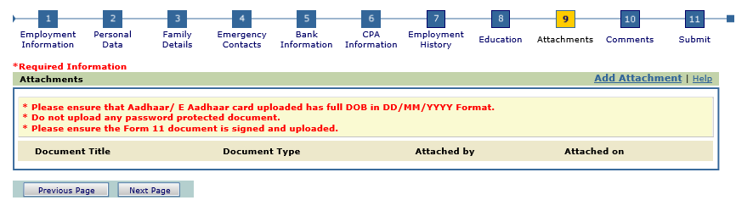

In the final page, select the check box option and click on ‘**Submit’** button.

You will reach the screen as shown below once your submission is successful.

